Write a C program to count distinct elements in an array

CODE :

#include <stdio.h>

void distict_elements(int a[], int n);

int main()

{

int size_array, i, arr[20];

scanf(“%d”, &size_array);

for(i=0; i<size_array; i++)

{

scanf(“%d”, &arr[i]);

}

distict_elements(arr, size_array);

return 0;

}

void distict_elements(int a[], int n)

{

int i, j;

for (i=0; i<n; i++)

{

for (j=0; j<i; j++)

{

if (a[i] == a[j])

break;

}

if (i == j)

printf(“%d “, a[i]);

}

}

Alogrithm :

Declare and input the array elements.

Traverse the array from the beginning.

Check if the current element is found in the array again.

If it is found, then do not print that element.

Else, print that element and continue.

Step 1: Start

Step 2:int are[],i;

Step 3:if(i<size_array)

{

distinct_element(arr,size_array)

}

Step 4:if(a[i]==a[j])

break;

else

i==j;

continue

Step 5:Stop

Flowchart:

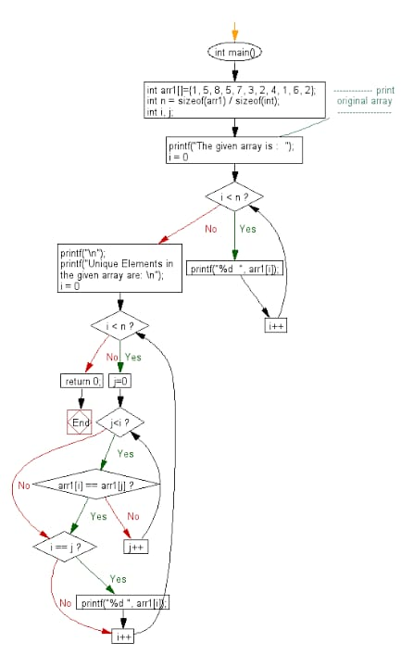

Output :

